DWH Test Result Summary
DQ Strategy


Table of contents
Summary 3
Test Team 3
Testing Process Description 3
Pre-requisites 3
Testing Approach 3
Smoke Testing 4
Critical Path Testing( using data reconciliation) 4
Extended Path Testing ( lowest priority checks) 4
New Defects Statistics 4
New Defects List 5
Recommendations 8
Attachments / Visualizations 8
Total Anomalies per Table – Bar Chart 8
Reconciliation Results by Table – Stacked Bar Chart 8
Reconciliation Status Distribution – Bar Chart 9
Reconciliation Status Distribution – Pie Chart 9
Bug Severity Distribution (Pie Chart, from Jira Export) 10
Bug Priority Distribution (Bar Chart, from Jira Export) 11

Summary
This report summarizes the results of DWH testing conducted on dwh_src_hw_db (Source) and dwh_hw_db (Target) databases, including landing, DWH, and dashboard (DM) layers. The focus was on:
- Data reconciliation across all layers
- Smoke testing for row-level integrity, key uniqueness, schema, referential integrity, and value sanity
- Extended testing to identify edge cases and potential data quality issues
- Bug logging and tracking in Jira (prefix DWH_)
Testing ensures completeness, consistency, and accuracy of data in the DWH and dashboards.

Test Team

TEST TEAM
# | Role | Name | Responsability
1 | QA Lead | Artsem Nikulin | Oversight of DWH testing, reconciliation, bug logging
2 | QA Analyst | Gabriela Cretu | SQL/Python reconciliation, smoke testing, extended path testing
3 | BI Developer | Gabriela Cretu | Dashboard validation, data mapping

Testing Process Description

Pre-requisites
- Executed scripts to create source, landing, DWH, and DM layers:
  - 1_create_sources_postgres.sql
  - 2_create_landing_postgres.sql
  - 3_create_DWH_layer_postgres.sql
  - 4_create_DM_layer_postgres.sql
- Verified table creation and initial data population.

Testing Approach

Smoke Testing
- Row-level integrity
- Uniqueness of keys
- Null values in key columns
- Schema validation
- Referential integrity
- Value sanity checks
- Data type and length checks
- Code references: 6_smoke_tests.sql, 7_smoke_tests_source.sql

Critical Path Testing( using data reconciliation)
- SQL-based reconciliation (FULL OUTER JOIN, lnd.reconciliation_results)
- Python-based reconciliation for flexibility and performance (Python_reconciliation.ipynb)
- Layers checked:
  - S1 & S2 → Landing
  - Landing → DWH
  - DWH → Dashboard (DM)

Extended Path Testing ( lowest priority checks)
- S1 Clients – middle_name nulls
- S2 Clients – valid_from / valid_to consistency
- S1 Sales – units > 0
- S2 Client Sales – future/missing sale dates
- S1 Products – missing product_name/cost
- S1 Channels – channel_location mapping
- Code reference: 8_extended_path.sql

New Defects Statistics

New defects statsistics
# | Severity |  | Priority
 | Type | Count | Type | Count
1 | Critical | 5 | Highest | 0
2 | Major | 8 | High | 9
3 | Minor | 14 | Medium | 18
4 | Trivial | 0 | Low | 0
Total | 27

New Defects List

New defects list
# | BUG_ID | Issue | Severity | Priority | Link
1 | SCRUM-1750 | The column location_name in table dwh.dwh_locations has length character varying(256) but should be character varying(100). | Major | Medium | Atlassian
2 | SCRUM-1749 | The column is_valid in table dwh.dwh_clients is defined as character(1) but should be character varying(1). This may cause ETL or validation failures. | Major | High | Atlassian
3 | SCRUM-1748 | The column channel_name in table dwh.dwh_channels has incorrect length. Expected character varying(30) but found character varying(50). | Major | Medium | Atlassian
4 | SCRUM-1747 | The column total_cost in table dm.dm_main_dashboard has an incorrect numeric precision. Expected numeric(18,4) but found numeric(16,4). This may cause rounding errors or ETL failures. | Critical | High | Atlassian
5 | SCRUM-1746 | During reconciliation between the S2 landing lnd_s2_client_sales table and the source s2.s2_client_sales table, 5 sales exist in the source table but are missing in the landing table. | Minor | Medium | Atlassian
6 | SCRUM-1745 | During reconciliation between the S2 landing lnd_s2_locations table and the source s2.s2_locations table, 4 locations exist only in the source table. | Minor | Medium | Atlassian
7 | SCRUM-1744 | During reconciliation between the S2 landing lnd_s2_locations table and the source s2.s2_locations table, 1 location exists only in the landing table. | Minor | Medium | Atlassian
8 | SCRUM-1743 | During reconciliation between the S1 landing lnd_s1_sales table and the source s1.s1_sales table, 176 sales records exist only in the source table. | Major | High | Atlassian
9 | SCRUM-1742 | During reconciliation between the S1 landing lnd_s1_products table and the source s1.s1_products table, 1 product record exists only in the landing table. | Minor | Medium | Atlassian
10 | SCRUM-1741 | During reconciliation between the S1 landing lnd_s1_clients table and the source s1.s1_clients table, 1 client record has a last name mismatch. | Minor | Medium | Atlassian
11 | SCRUM-1740 | During reconciliation between the S1 landing lnd_s1_clients table and the source s1.s1_clients table, 1 client record has a phone number mismatch. | Minor | Medium | Atlassian
12 | SCRUM-1739 | During reconciliation between the S1 landing lnd_s1_channels table and the source s1.s1_channels table, 2 records exist in the source database that are missing from the landing table. | Minor | Medium | Atlassian
13 | SCRUM-1738 | During reconciliation between the S1 landing lnd_s1_channels table and the source s1.s1_channels table, 1 record was found where the channel_name in landing does not match the corresponding channel_name in the source database. | Minor | Medium | Atlassian
14 | SCRUM-1737 | During reconciliation between the S1 landing lnd_s1_channels table and the source s1.s1_channels table, 5 records were found where the channel_location in landing does not match the corresponding channel_location in the source database. | Minor | Medium | Atlassian
15 | SCRUM-1736 | During reconciliation between the landing sales tables (lnd_s1_sales / lnd_s2_client_sales) and DWH dwh_sales, 181 sales records exist only in DWH and are missing in the landing layer. | Major | High | Atlassian
16 | SCRUM-1735 | During reconciliation between the DWH dwh_clients table and landing clients (lnd_s1_clients / lnd_s2_clients), 3 client records have mismatched phone numbers between landing and DWH. | Minor | Medium | Atlassian
17 | SCRUM-1734 | During reconciliation between the DWH dwh_clients table and landing layer clients (lnd_s1_clients / lnd_s2_clients), 1 client record has a mismatched last_name value between landing and DWH. | Minor | Medium | Atlassian
18 | SCRUM-1733 | During reconciliation between the DWH Sales fact and the Dashboard (dm_main_dashboard), 7 sales records show mismatched total_cost values between the dashboard and DWH calculation (quantity * product_cost). | Minor | Medium | Atlassian
19 | SCRUM-1732 | During reconciliation between the DWH channels table (dwh_channels) and the landing channels data, 1 channel record has a name mismatch (Mismatch in channel_name). | Minor | Medium | Atlassian
20 | SCRUM-1731 | During reconciliation between the DWH Sales fact and the Dashboard (dm_main_dashboard), 2 sales records exist in the dashboard but have no corresponding record in the DWH (Only in dashboard). | Minor | Medium | Atlassian
21 | SCRUM-1730 | During reconciliation between the DWH Sales fact and the Dashboard (dm_main_dashboard), 7 sales records show mismatched total_cost values between the dashboard and DWH calculation (quantity * product_cost). | Major | Medium | Atlassian
22 | SCRUM-1729 | 43 sales records have mismatched phone numbers between dm_main_dashboard and the DWH client dimension. | Major | High | Atlassian
23 | SCRUM-1728 | During reconciliation between the DWH Sales fact and the Dashboard (dm_main_dashboard) view, we identified 67 sales records where the client email in the dashboard does not match the email stored in the DWH client dimension. | Major | Medium | Atlassian
24 | SCRUM-1727 | Sales transactions in s1_sales reference product IDs that do not exist in s1_products. This breaks referential integrity. | Critical | High | Atlassian
25 | SCRUM-1726 | The deduplicated warehouse layer (s2_locations) still contains duplicate IDs, suggesting incorrect ETL logic. | Critical | High | Atlassian
26 | SCRUM-1725 | The lnd_s1_clients table contains duplicate client_ids. This breaks uniqueness assumptions for primary keys and affects sales-to-client relationships. | Critical | High | Atlassian
27 | SCRUM-1724 | The lnd_s2_locations table contains duplicate primary keys (location_id). This violates uniqueness rules and may cause incorrect joins in downstream transformations. | Critical | High | Atlassian

Recommendations
- Automate reconciliation scripts for future DWH updates
- Implement stricter validation at source ingestion stage
- Review data mappings for dashboards, especially for edge cases
- Periodically monitor key metrics and anomalies in S1/S2 → Landing
- Standardize middle_name, product_name, and date validations

Attachments / Visualizations

Total Anomalies per Table – Bar Chart
Shows the total number of issues detected per table. Provides a quick overview of which tables contain the most discrepancies during reconciliation.
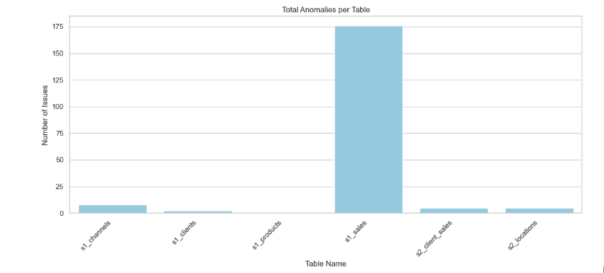

Reconciliation Results by Table – Stacked Bar Chart
Displays the breakdown of issue types per table, categorized by reconciliation status:
- Only in Source – Records missing in the target.
- Only in Target/Landing – Records missing in the source.
- Mismatch – Records that exist in both but have differing column values.
Helps identify both the volume and type of data inconsistencies across tables.
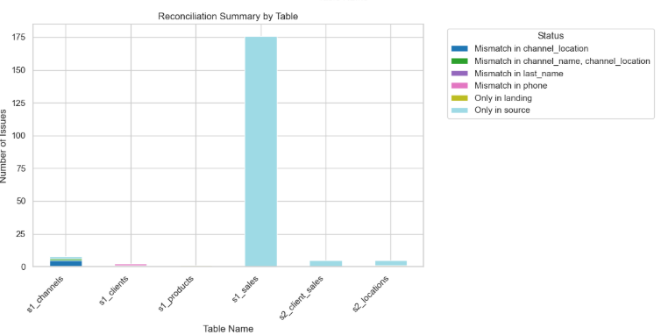

Reconciliation Status Distribution – Bar Chart
Aggregates all tables and shows counts of each reconciliation status, allowing quick understanding of the overall
distribution of issue types.
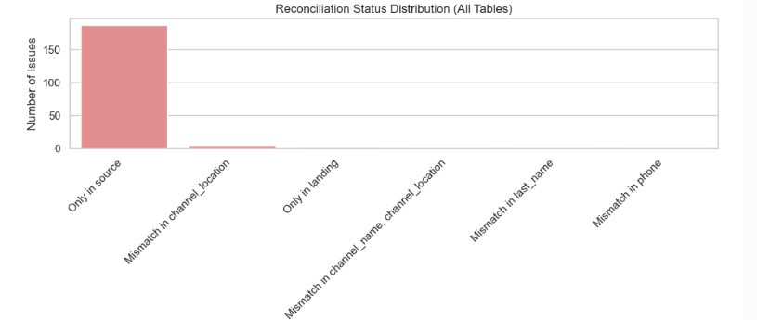

Reconciliation Status Distribution – Pie Chart
Presents the proportion of each reconciliation status across all tables as percentages, providing an easy-to-read
summary of data quality issues.
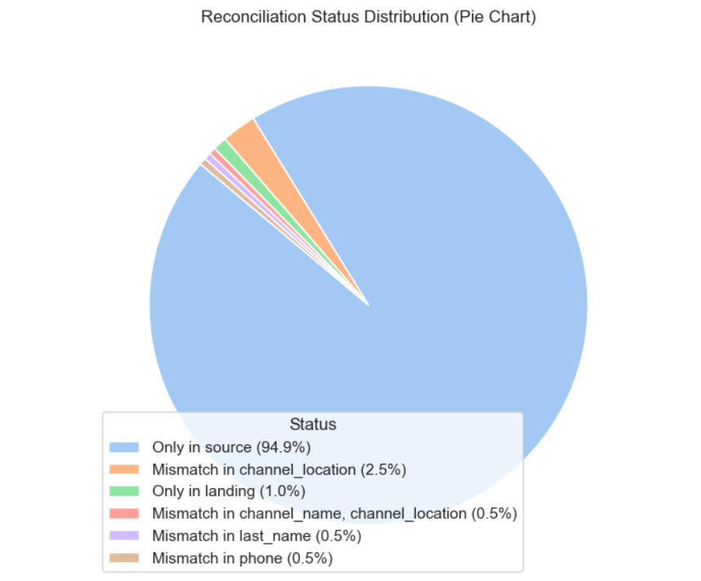

Next, I implemented a bugs profiling to see the type of severity or priority among the bugs distribution

Bug Severity Distribution (Pie Chart, from Jira Export)
A bar chart showing the number of bugs assigned to each priority level (e.g., Critical, High, Medium, Low).
Purpose: Highlights which bugs require immediate attention from the development/BI team and supports resource planning for fixing issues.
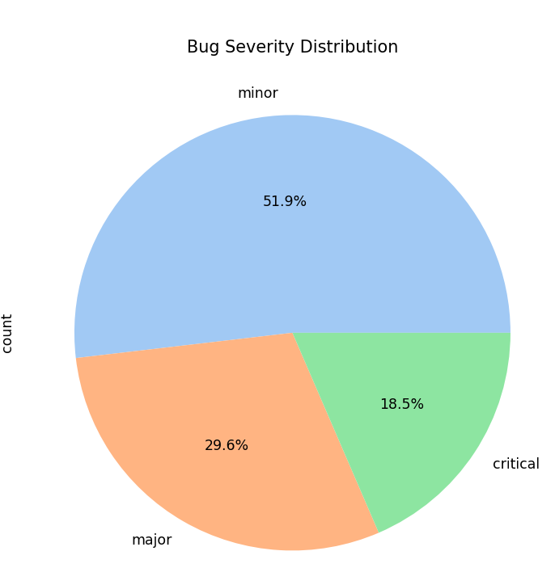

Bug Priority Distribution (Bar Chart, from Jira Export)
If time-stamped data is available, this line chart can show trends of flagged records per table or layer over the testing period.
Purpose: Identifies patterns or recurring problems, enabling proactive measures to prevent repeated issues in future DWH loads.
